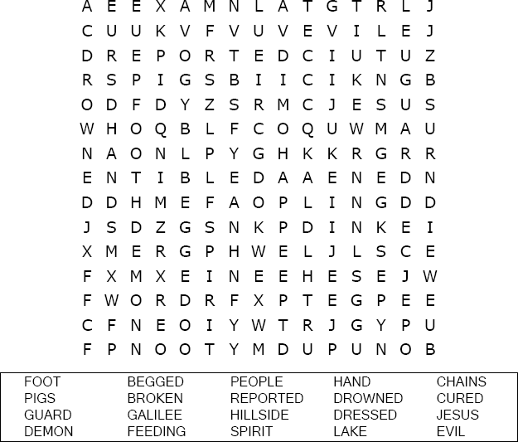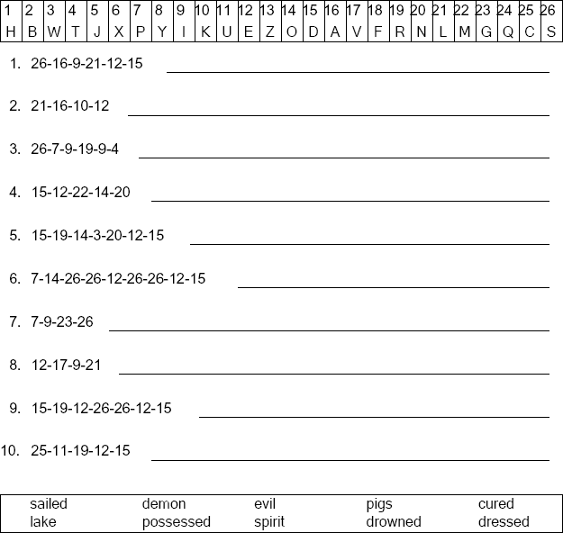

**St. Paul’s UCC**

**301 W. Penn Avenue**

**Robesonia, PA 19551**

**610-621-5770**

Luke 8:35

Copyright © Sermons4Kids, Inc. May be reproduced for Ministry Use

Children’s Worship Bulletin

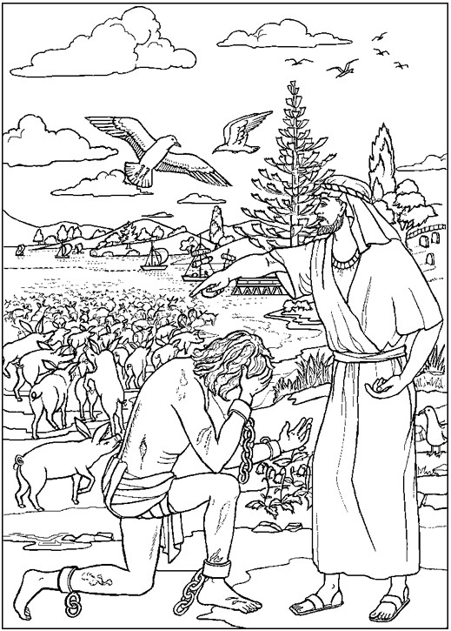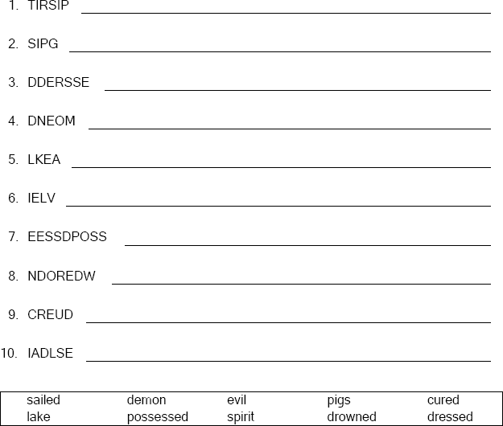



Unscramble the letters and write the word correctly .

Copyright © ABDA Acts - Arts and Publishing Used by permission.