The Maze

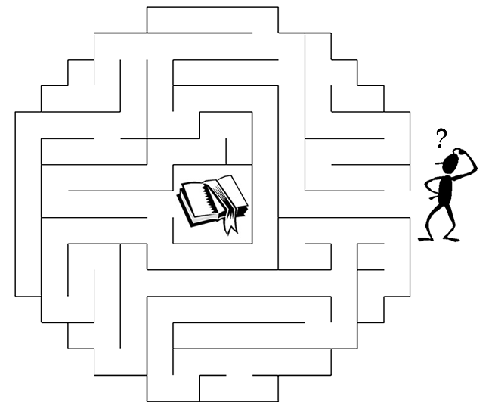
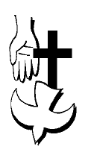
Copyright © Sermons4Kids, Inc.
May be reproduced for Ministry Use

Children’s Worship Bulletin

The Unseen Power Unseen Power

John 16:12-13
Word Search

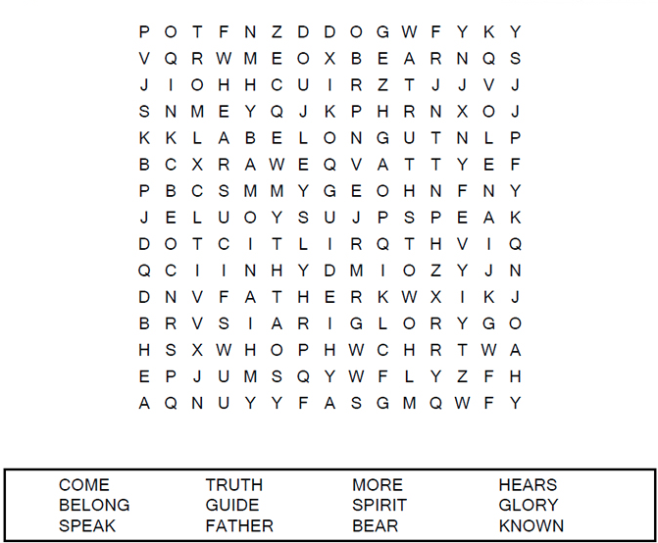

St. Paul’s UCC
301 W. Penn Avenue
Robesonia, PA 19551
610-621-5770

Spiral

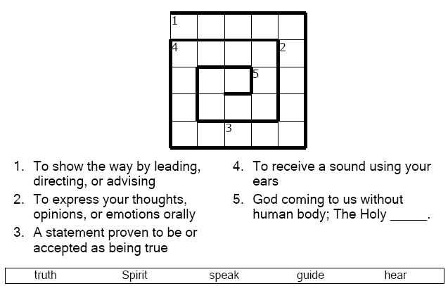

But when he, the Spirit of Truth, comes, he will guide you into all truth. He will not speak on his own; he will speak only what he hears, and he will tell you what is yet to come.
John 16:13 (NIV)

Color Me!e!

